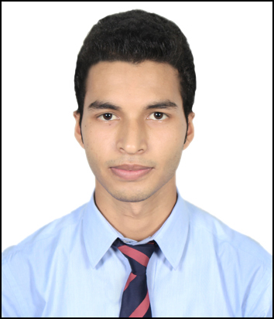
RESUME

SUJAY KARMAKAR
House No - 11, Rupnagar,
Bhangagarh, Near GMCH, Guwahati-781032
Contact No: +91 8011116380, 8876579294
Email ID: karmakarsujay5@gmail.com

CAREER OBJECTIVE:

To seek challenging assignment and responsibility, with an opportunity for growth and career advancement as successful achievements.

EDUCATIONAL QUALIFICATION:

Examination Passed | School/College | Board/University | Year of Passing
B.A | Chilarai College | Gauhati University | 2016
H.S. | Kachakhana HS School | A.H.S.E.C. | 2013
H.S.L.C. | Kachakhana HS School | SEBA | 2011

OTHER QUALIFICATION:

- I have completed 3 months Vocational training Course in Selling Skills from ICICI Academy for Skills.
Course Highlights:
- Communication Skills.
- Life Skills.
- Selling Skills.
- Customer Service.
- Basic Computer Knowledge.

COMPUTER KNOWLEDGE:

- 18 Months Course of Post Graduate Diploma in Computer Application (PGDCA) from NRDS.
Course Highlights:
- Basic Computer.
- DTP.
- Tally.
- Internet.

LANGUAGES KNOWN:

Languages | Speak | Read | Write
English | ✓ | ✓ | ✓
Hindi | ✓ | ✓ | ✓
Assamese | ✓ | ✓ | ✓
Bengali | ✓ | ✓ | ✓

PERSONAL DETAILS:

- Father’s Name : Jogesh Karmakar
- Date of Birth : 26/11/1995
- Permanent Address : Vill+P.O. : Borocharai Khola, P.S. : Golakganj,
Dist: Dhubri, Assam, Pin: 783334
- Hobbies and Interests : Playing Computer Games, Playing Cricket,
Listening music.

Date:
Place: Sujay Karmakar

